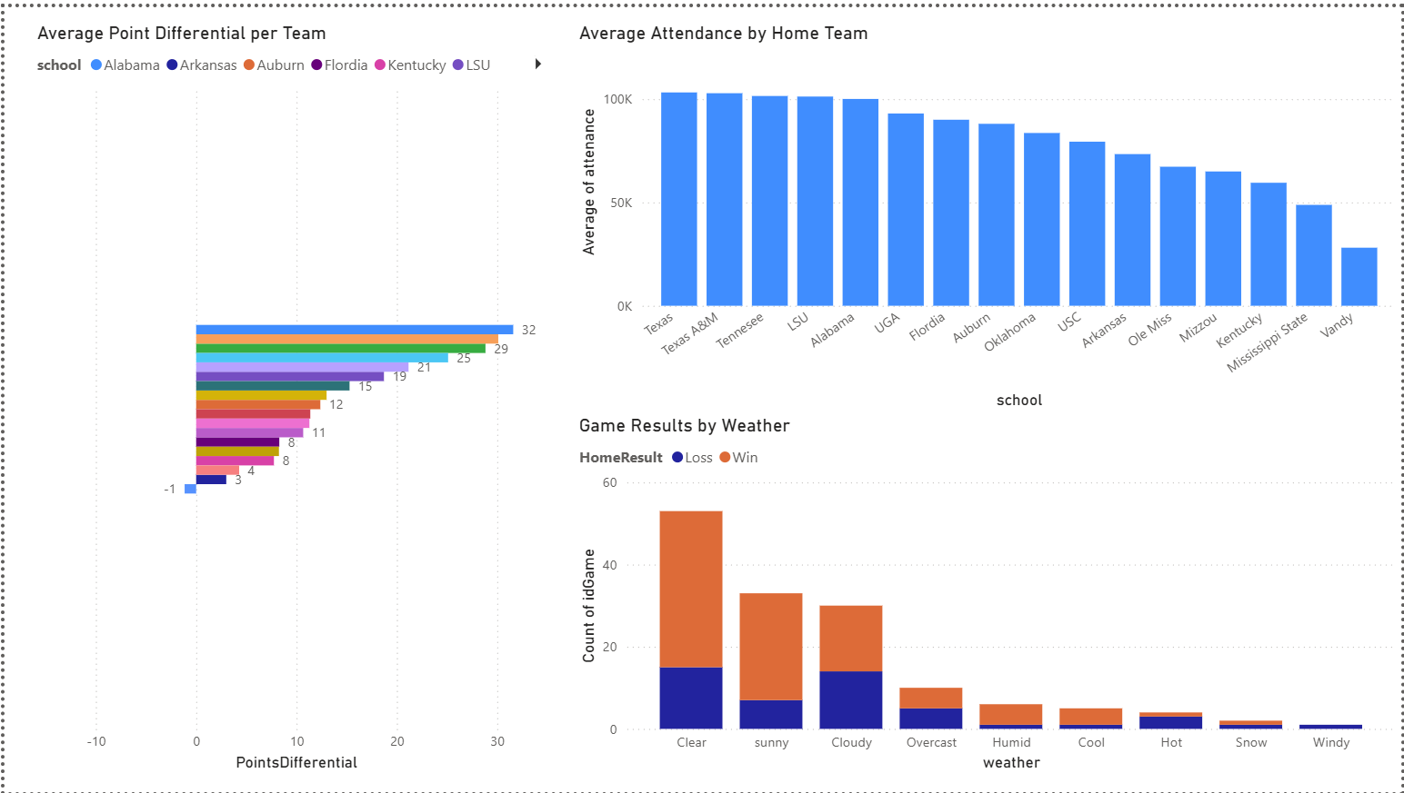
Visualizations: Managerial Reasoning
Average Point Differential per Team:
The average point differential helps determine which team is actually dominating rather than just winning games by a lucky close margin. Coaching staff can use this as a better metric than season record to understand how well the team is performing. The SEC conference could also use this as a metric to determine which teams are leading the conference and, if teams have similar records, which are likely to reach the SEC championship.
Average Attendance by Home Team:
This bar chart shows which SEC teams draw the largest crowds at home. Managers can learn about fan engagement and brand strength from average attendance numbers. High average attendance can signal a strong fan base, a good brand, and a strong gameday experience. Low average attendance could be a red flag for marketing, scheduling, and brand strength. These numbers can also help managers understand the facility's ROI.
Game Results by Weather:
Knowing a team's ability to persevere through different weather conditions helps gauge its ability to travel for bowl games, late-season games, or nonconference opponents. This data can help coaching staff decide whether to prioritize practicing in conditions different from those of the home team.

5 Complex Query
Referee strictness
SELECT
r.refereename, AVG(ght.penalities) AS avg_penalties_per_game,
CASE
WHEN AVG(ght.penalities) >= 10 THEN 'Strict'
WHEN AVG(ght.penalities) >= 5 THEN 'Average'
ELSE 'Lenient'
END AS strictness_category
FROM referee AS r
JOIN game_has_referee AS ghr
ON ghr.idReferee = r.idreferee
JOIN game_has_teams AS ght
ON ght.Game_idGame = ghr.idGame
GROUP BY
r.refereename
ORDER BY
avg_penalties_per_game DESC;
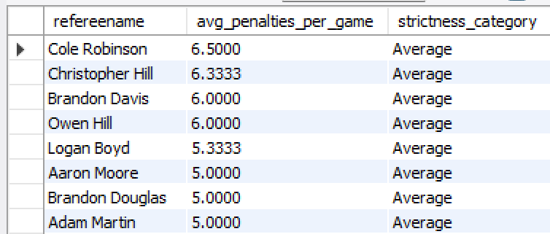

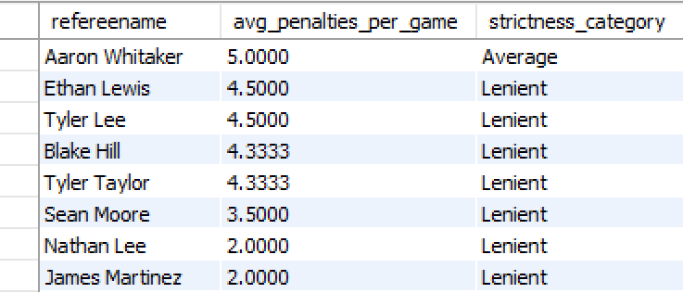

Managerial Reasoning:
This query averages the overall penalties that refs make to gauge their level of strictness. Knowing how strict referees are can help coaching staff prepare players for the flow of the game and plan game strategy according to how strict referees are.

## Query 2

# Query

Average point differential by team- error game team stats

```sql

SELECT
t.Teamname,
AVG(g.totalhome - g.totalaway) AS avg_point_diff
FROM team AS t
JOIN game_has_teams AS gts
ON t.idteam = gts.Team_idTeam
JOIN games AS g
ON g.idgames = gts.Game_idGame
GROUP BY t.Teamname
ORDER BY avg_point_diff DESC;

```
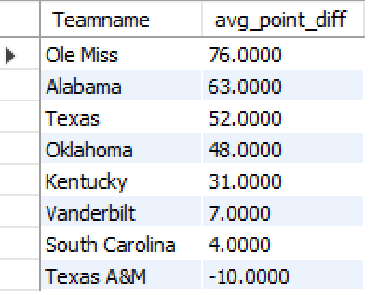

# Managerial Reasoning

Point differential is a better measure of team strength than wins alone.
Teams with high differentials are dominating games, not winning by luck.
Conference leaders and coaching staff can use this to judge true performance and predict championship contenders.

---

## Query 3- we do not have a access to view so i can’t run it

# Query

Average home attendance using a view

```sql
-- Step 1: Create the view
CREATE OR REPLACE VIEW home_attendance AS
SELECT
t.teamname,
g.attendance
FROM games AS g
JOIN team AS t
ON g.Stadium_idStadium = t.homestadiumID;

-- Step 2: Query the view
SELECT
teamname,
AVG(attendance) AS avg_home_attendance
FROM home_attendance
GROUP BY teamname
ORDER BY avg_home_attendance DESC;
```

# Managerial Reasoning

Attendance shows the strength of a teams brand and fan engagement.
High attendance supports revenue, stadium investments, and marketing plans.
Low attendance can show weak fan support or gaps in game day experience.

---

## Query 4

# Query

Weather impact on scoring

```sql
WITH weather_points AS (
SELECT
weather,
(totalhome + totalaway) AS total_points
FROM games
)
SELECT
weather,
AVG(total_points) AS avg_points_scored
FROM weather_points
GROUP BY weather
ORDER BY avg_points_scored DESC;

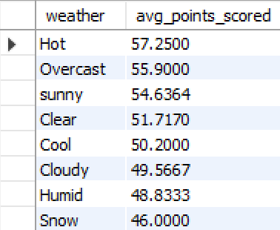```

# Managerial Reasoning

Weather affects scoring and team performance.
This helps coaches prepare for bowl games, late season travel, and games in unfamiliar climates.
Teams can decide if they should train more in rain, heat, or cold depending on the results.

---

## Query 5

# Query

Turnover impact on win percentage

```sql

SELECT
t.Teamname,
AVG(ght.turnovers) AS avg_turnovers,
SUM(
CASE
WHEN ght.Team_idTeam = t.idteam
AND (
(ght.Team_idTeam = t.idteam AND g.totalhome > g.totalaway)
) THEN 1
ELSE 0
END
) AS wins,
COUNT(*) AS total_games,
(
SUM(
CASE
WHEN ght.Team_idTeam = t.idteam
AND (
(ght.Team_idTeam = t.idteam AND g.totalhome > g.totalaway)
) THEN 1
ELSE 0
END
) / COUNT(*)
) AS win_percentage
FROM team AS t
JOIN game_has_teams AS ght
ON t.idteam = ght.Team_idTeam
JOIN games AS g
ON g.idgames = ght.Game_idGame
GROUP BY t.Teamname
ORDER BY win_percentage DESC;

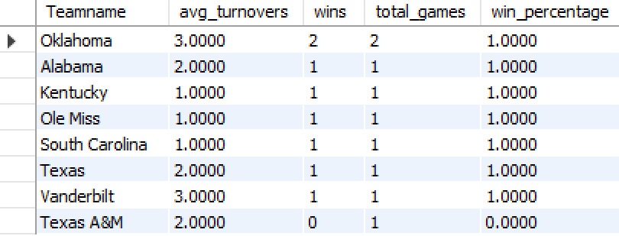
```

# Managerial Reasoning

Turnovers have a big effect on game outcome.
Teams that protect the ball win more.
Coaches can use this to focus training on ball security, quarterback decision making, and forcing defensive turnovers.
This gives a clear picture of how much turnovers affect winning in the SEC.

